EDITOR CHIEF PAUL NEWS Magazine Breaking 24/7 365 since Request for Arresting Accused Newly appointed COAS LT GENERAL SYED HAFIZ ASIM MUNIR BAJWA AND HIS ACCUSED FAMILY AND HIS ACCUSED MILITARY UNDER HIS COMMAND as mentioned in the details below
Accused Waqas Mehmood cell# 03330977677 Accused Raja Amjad, Abdul Qudoos and Abdul Rauf and Accused SI Amjad Pervaiz cell# 03005181167 along with Islamic Suni Barelvi Deobandi Molvi Ulama Imam Masjid Madrasa kaladum tanzeem Terrorists Daesh Taliban lashqars Sippa Sahaba ISIS Alqaida Sleeper Cells ISI Pakistan Army Suni citizens of Pakistani People Mobs riots in Rawalpindi are trying to find me and family to kill us by misusing blasphemy laws and they are accusing me for blasphemy against Prophet Muhammad and against his Quran and against his first 3 companions and their followers Muslims who stolen and Snatched my properties and our fundamental human rights through Persecution, I Condemn them all to Physical Eternal Fire along with their deeds with them Spiritually souls of unforgivable and unforgettable accountable sins crimes sinners tormenting Day and Night Forever and ever in the lake that burns with Fire and Brimstone to the Bottomless Pit Eternally in Physical Infinity Eternity as Written in The Holy Bible, no Church, no Bishop, no Priest, no Reverend, no Exorcist, no Father and no Pastor is helping me and my family may Lord Jesus Christ take me and my family out of the this Criminal Terrorist Country Pakistan Islamic Republic of Pakistan.
I Paul Eliya and my family, therefore, request Churches in Christian countries to arrange our immediate travel OUT OF PAKISTAN ASAP through Resources of God in the best interests of HOLY GOD Bible Jesus Christ and Christianity's fundamental human rights.
https://priestfatherexorci.wixsite.com/christianchurch https://youtu.be/Q8fK9Eq9TNg https://youtu.be/mSYl0PCye2c https://youtu.be/sFNt6B3fT2g
https://youtu.be/M1lKUg_aAk8 CONTACT 03455333058 03145550432
Email PAULELIYA07@GMAIL.COMhttps://youtu.be/Q8fK9Eq9TNg CV Personal information DATED 25-12-2025
Name : Paul Eliya CNIC : 3740503659809 Passport : LL1019802 Nationality : Pakistan
Date of Birth : 30-10-1992 Phone : 03145550432, 03455333058 Father : Hassan Syed Gender : Male Status : Single WANT TO LEAVE PAKISTAN FOREVER Religion : https://youtu.be/mSYl0PCye2c

Qualifications
1. Matriculation with 90% Marks at SLS School Lalazar Tulsa Road Rawalpindi 46000
2. Fsc Pre Engineering 1st year 63% marks from 502 Model College Adiala Road Lalazar Rawalpindi 46000
3. Diploma in ACCA Accountancy Financial and Management Accounting UK, Roots International Schools G-8, H-8, Islamabad Capitol Territory 44000
4. Institute of Space Technology Sparco Centre of Aviation EASA B1 and B2, all Basics First Attempt Passed Interview PKR 4,60,000 Three Years Fee Wavier Scholarship Awarded by Sir Hamza Ashraf, Islamabad 44000
5. Web Designer and Developer Online Web hosting https://priestfatherexorci.wixsite.com/ngo-unhcr-churchpaul
6. Pastor Course ZBS ongoing, PBCI, PBCS Opposite Red Onion Restaurant Pakistan Army GHQ Defence Ministry Road Saddar Rawalpindi 46000
7. Teacher Human Rights Activist Standards Operating Procedures Laws Rules Regulations Faithful Intelligence Policies Maker for Free Unconditionally conditionally with no compromise on What is Right I am leaving you the best of myself https://priestfatherexorci.wixsite.com/christianchurch

Hobbies and other Talents DATED 25-12-2025
Singing (Singer),Poetry(Poet),Painting and Bodybuilding Championship
Background Details History DATED 25-12-2025
(& Super Natural Eternal Powers i.e & e.g https://priestfatherexorci.wixsite.com/ngo-unhcr-churchpaul)
https://youtu.be/mSYl0PCye2c

PAKISTAN CHRISTIAN NEWS
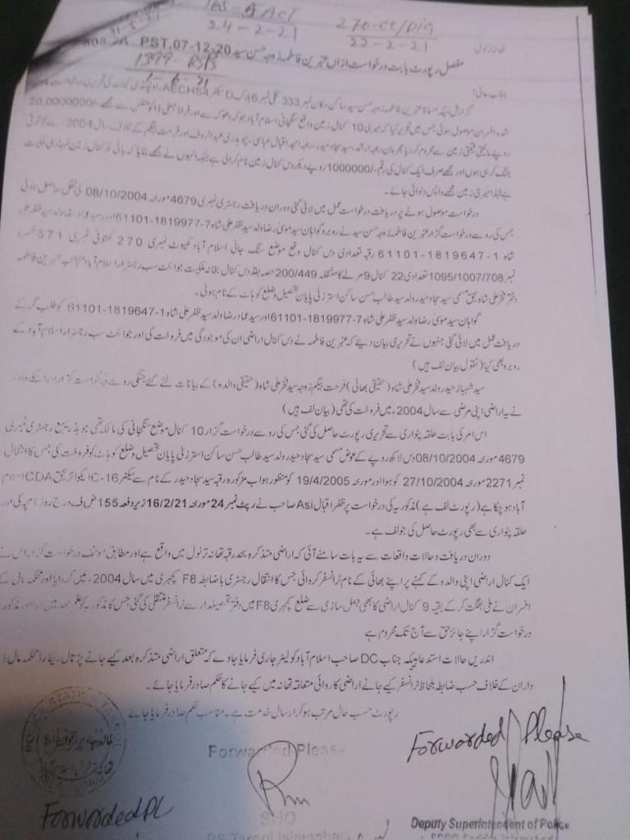
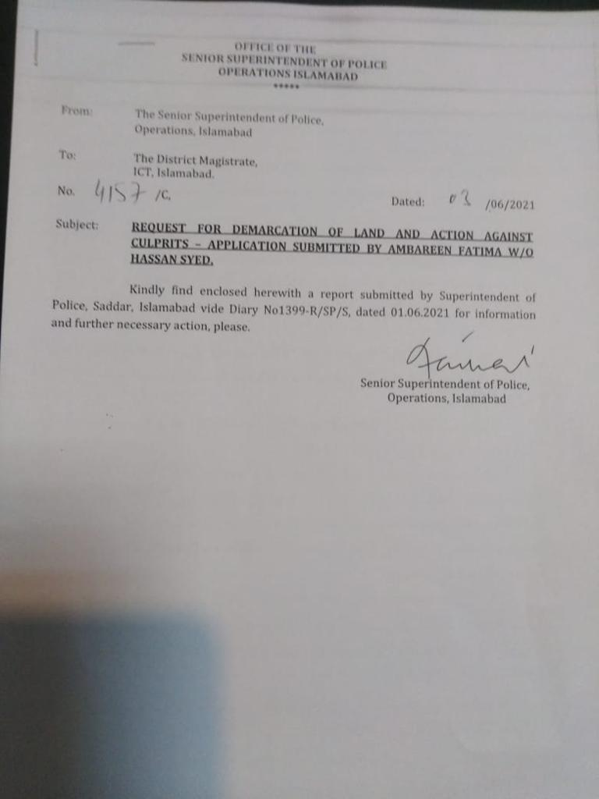
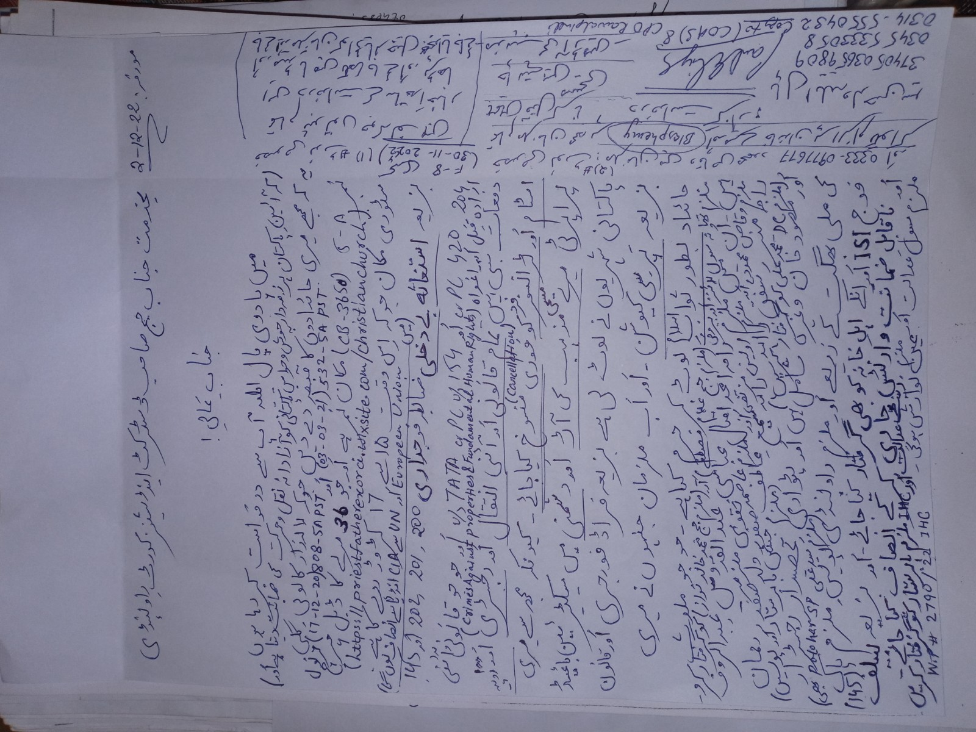
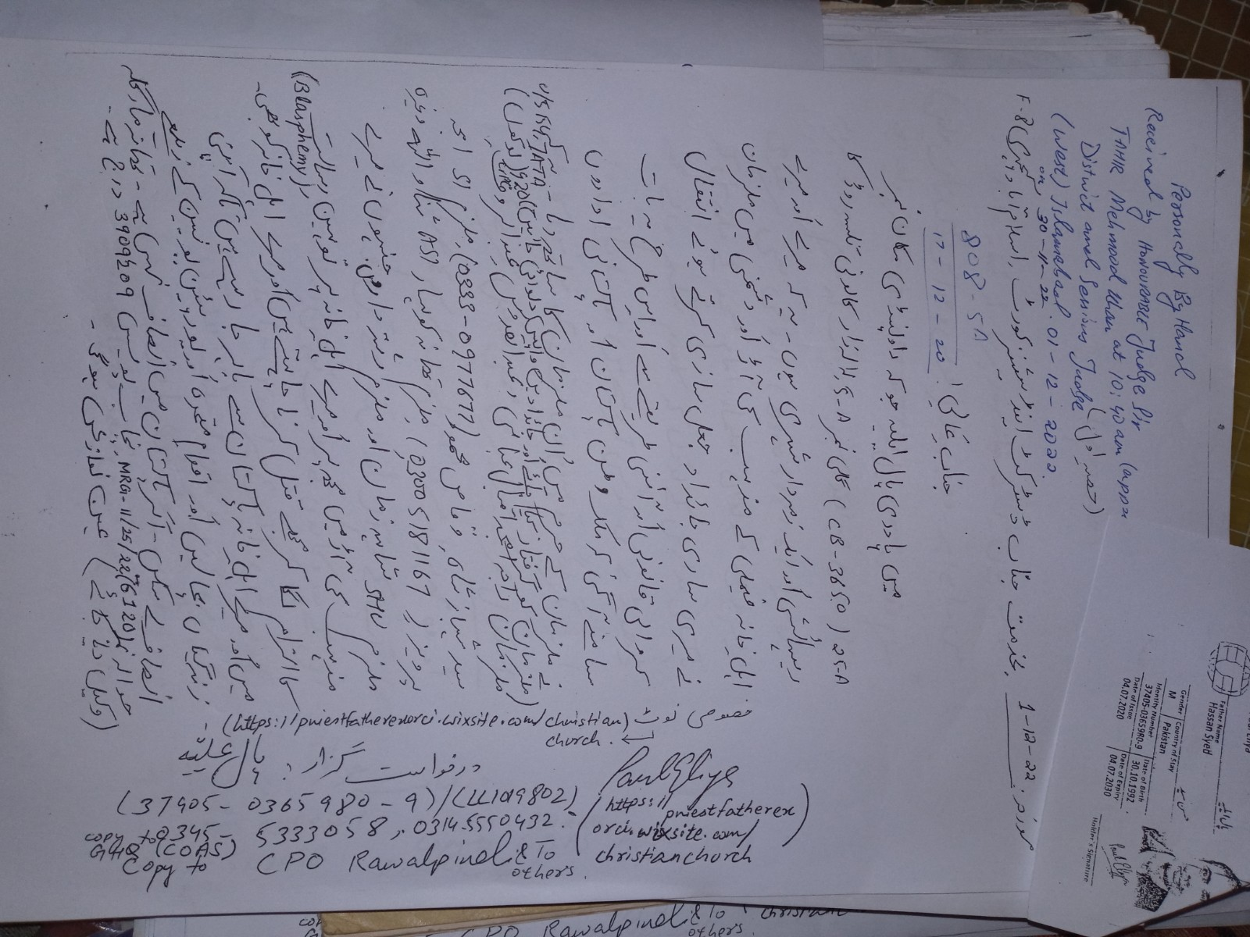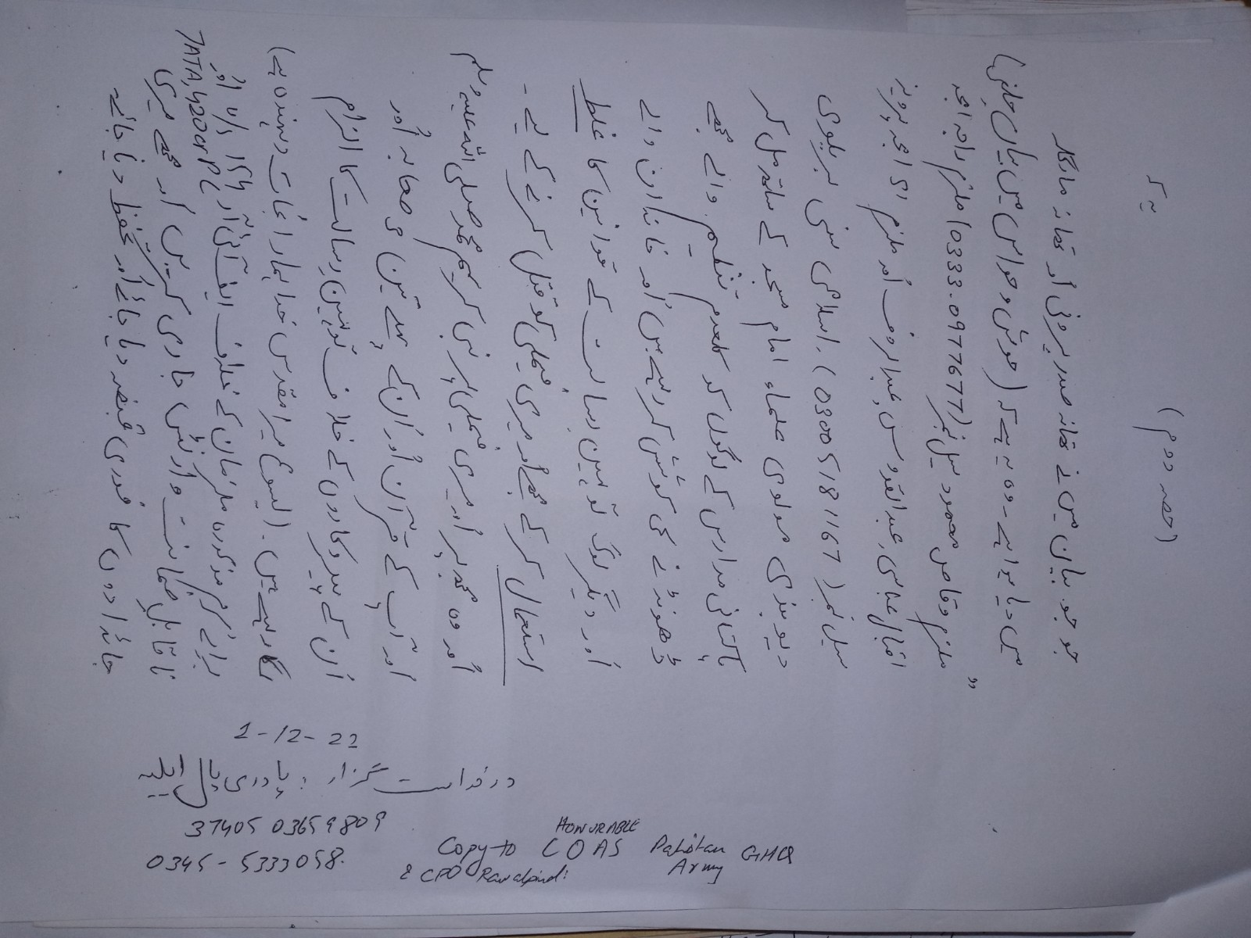
To Elizabeth Pollard Caseworker National Safeguarding Team to the Church of England The Archbishops Council, Church House Great Smith Street, London SW1P 3AZ Direct Dial: 0207 898 1710A FOR EMERGENCY REQUEST FOR FUNDS FOR OUR TRAVEL OUT OF PAKISTAN And EUROPEAN UNION and UNITED NATIONS and Farrukh Saif Foundation EMERGENCY REQUEST FOR FUNDS FOR OUR TRAVEL OUT OF PAKISTAN From Paul Eliya and family Wish you a Happy Mary Christmas Complain and Feedback This is the list of 8 Reverends who refused to take me and my family under the pastoral care of a bishop in the Christian Church 1: Diocese: Faisalabad Information Bishop of Faisalabad and Deputy Moderator of the Church of PakistanThe Rt Revd John Samuel Address:Bishop's House, PO Box 27, Mission road, Gojra Dist Toba Tek Sing, PakistanOffice:+92 (0)46 351 4689 Email:Click here for email jsamuel51@Gmail.com 2: Diocese: Karachi Information Bishop of Karachi The Rt Revd Frederick John Address:Trinity Close, Abdullah Haroon Road, Karachi, 4, Pakistan Office:+92 021 356556913 Email:Click here for email fredrickjohn0063@gmail.com 3: Diocese: Lahore Information Bishop of LahoreThe Rt Revd Irfan Jamil Address:Bishopsbourne, Cathedral Close, The Mall, Lahore, 54000, Pakistan Office:+92 (0)42 3723 3560 Fax:+92 (0)42 3712 0766 Email:Click here for email Address:www.lahorediocese.com Companion Link Manchester 9thbishopoflahore@gmail.com 4: Diocese: Multan Information Bishop of MultanThe Rt Revd Leo Rodrick Paul Address:Multan Cathedral of St Mary the Virgin, 113 Qasim road,, P O Box 204, Multan Cantt, Pakistan Office:+92 (0)61 458 3694 Email:Click here for email bishop_mdcop@live.com 5: Diocese: Peshawar Information Bishop of PeshawarThe Most Revd Humphrey PetersAddress:St Johns Cathedral, 1 Sir Syed Road, Peshawar, 25000, Pakistan Office:+92 (0)91 527 6519 Email:Click here for email bishopdop@Hotmail.com 6: Diocese: Raiwind Information Bishop of Raiwind & Moderator of the Church of PakistanThe Most Revd Dr Azad Marshall Address:17 Warris Road, Lahore, 54000, Pakistan Office:+92 (0)42 3758 8950 Email:Click here for email mailto: bishop@Ict-edu.org 7: Diocese: Sialkot Information Bishop of Sialkot The Rt Revd Alwin John Samuel Address:Lal Kothi Bara Pathar, Christian Town, Sialkot, 2, Pakistan Office:+92 052 4264828 Email:Click here for email alwinsialkot@Gmail.com 8: Diocese: Hyderabad Information Bishop of Hyderabad The Rt Revd Kaleem JohnAddress:27 - Liaqat Road, Civil Lines, Hyderabad, 71000, PakistanOffice:+92 0301 2445690 Email:Click here for email Kaleemjohn@aol.com However We are waiting for Farrukh Harrison Saif Foundation has not helped me and my family yet, and did not reach us to help us and no church in Pakistan is helping us for our travel to Dubai because Reason Accused Waqas Mehmood cell# 03330977677 Accused Raja Amjad, Abdul Qudoos and Abdul Rauf and Accused SI Amjad Pervaiz cell# 03005181167 along with Islamic Suni Barelvi Deobandi Molvi Ulama Imam Masjid Madrasa kaladum tanzeem Terrorists Daesh Taliban lashqars Sippa Sahaba ISIS Alqaida Sleeper Cells ISI Pakistan Army Suni citizens of Pakistani People Mobs riots in Rawalpindi are trying to find me and family to kill us by misusing blasphemy laws and they are accusing me for blasphemy against Prophet Muhammad and against his Quran and against his first 3 companions and their followers Muslims who stolen and Snatched my properties and our fundamental human rights through Persecution, I Condemn them all to Physical Eternal Fire along with their deeds with them Spiritually souls of unforgivable and unforgettable accountable sins crimes sinners tormenting Day and Night Forever and ever in the lake that burns with Fire and Brimstone to the Bottomless Pit Eternally in Physical Infinity Eternity as Written in The Holy Bible I am unable to find some support from the Anglican church in Pakistan. There are 8 dioceses, and this link takes me to the page on the Anglican Communion website where if I click on the relevant diocese, it gives me contact details for the diocese.https://www.anglicancommunion.org/structures/member-churches/member-church.aspx?church=pakistanable What I do now, no Church, no Bishop, no Priest, no Reverend, no Exorcist, no Father and no Pastor is helping me and my family may Lord Jesus Christ take me and my family out of the this Criminal Terrorist Country Pakistan Islamic Republic of Pakistan. I Paul Eliya and my family, therefore, request Churches in Christian countries to arrange our immediate travel OUT OF PAKISTAN ASAP through Resources of God in the best interests of HOLY GOD Bible Jesus Christ and Christianity's fundamental human rights. regards Paul Eliya 03455333058, 03145550432 https://priestfatherexorci.wixsite.com/christianchurch https://youtu.be/Q8fK9Eq9TNg CV Personal information Name : Paul Eliya CNIC : 3740503659809 Passport : LL1019802 Nationality : Pakistan Date of Birth : 30-10-1992 Phone : 03145550432, 03455333058 Father : Hassan Syed Gender : Male Status : Single WANT TO LEAVE PAKISTAN FOREVER Religion : https://youtu.be/mSYl0PCye2c Qualifications 1. Matriculation with 90% Marks at SLS School Lalazar Tulsa Road Rawalpindi 46000 2. Fsc Pre Engineering 1st year 63% marks from 502 Model College Adiala Road Lalazar Rawalpindi 46000 3. Diploma in ACCA Accountancy Financial and Management Accounting UK, Roots International Schools G-8, H-8, Islamabad Capitol Territory 44000 4. Institute of Space Technology Sparco Centre of Aviation EASA B1 and B2, all Basics First Attempt Passed Interview PKR 4,60,000 Three Years Fee Wavier Scholarship Awarded by Sir Hamza Ashraf, Islamabad 44000 5. Web Designer and Developer Online Web hosting https://priestfatherexorci.wixsite.com/ngo-unhcr-churchpaul 6. Pastor Course ZBS ongoing, PBCI, PBCS Opposite Red Onion Restaurant Pakistan Army GHQ Defence Ministry Road Saddar Rawalpindi 46000 7. Teacher Human Rights Activist Standards Operating Procedures Laws Rules Regulations Faithful Intelligence Policies Maker for Free Unconditionally conditionally with no compromise on What is Right I am leaving you the best of myself https://priestfatherexorci.wixsite.com/christianchurch Hobbies and other Talents Singing (Singer),Poetry(Poet),Painting and Bodybuilding Championship Background Details History (& Super Natural Eternal Powers i.e & e.g https://priestfatherexorci.wixsite.com/ngo-unhcr-churchpaul) https://youtu.be/mSYl0PCye2c https://youtu.be/sFNt6B3fT2g https://youtu.be/M1lKUg_aAk8 CONTACT 03455333058 03145550432 Email PAULELIYA07@GMAIL.COM CONFIDENTIAL NOTICE This message is intended solely for the addressee(s) in the first instance and may contain confidential information. If you are not the intended recipient, please notify the sender, delete the message from your system immediately and do not disclose the contents to any other party. PAKISTAN CHRISTIAN NEWS Attachments area Preview YouTube video TRIBUTE TO FARRUKH HARRISON SAIF FOUNDATION https://priestfatherexorci.wixsite.com/christianchurch Preview YouTube video na pooch parizadon se full song || parizaad drama || song by syed asrar Preview YouTube video 𝗢𝗦𝗧 𝗣𝗮𝗿𝗶𝘇𝗮𝗮𝗱 𝗨𝗻𝗽𝗹𝘂𝗴𝗴𝗲𝗱 | 𝗔𝘀𝗿𝗮𝗿 𝗦𝗵𝗮𝗵 | 𝗣𝗮𝗿𝗶𝗭𝗮𝗮𝗱𝗢𝘀𝘁 | 𝗛𝗨𝗠 𝗧𝗩 𝗗𝗿𝗮𝗺𝗮 | 𝗢𝗳𝗳𝗶𝗰𝗶𝗮𝗹 𝗩𝗶𝗱𝗲𝗼
EDITOR CHIEF PAUL NEWS

